**File:** **David_Georgiev_12_1eea4f.rb**

Task:

|  |
| --- |
| #Develop a program named FirstName_LastName_ClassNumber_1eea4f.rb |
|  |
| #1. you are given an argument for a folder with files; |
| #1.1 if there are other arguments they should be discarded |
| #2. file names in this folder are in the form First_Last_digits.rb; |
| #3. find all the students that have 5 letters in their second name; |
| #4. Sort the result by Last Name ASC. |
| #5. Produce a result in CSV format named result.csv: |
|  |
| # FirstName1,LastName1 |
| # FirstName2,LastName2 |
| # ... |
| # FirstNameN,LastNameN |

Code:

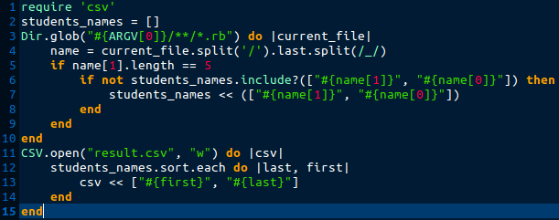

Errors:

* In line 5:in `block in <main>': undefined method `length' for nil:NilClass (NoMethodError)
* Check for files format is missing

New code:

